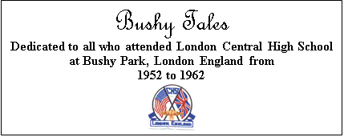

Issue #7 July 2023 Volume #23

Gary Schroeder (55), Founding Editor (1936-2016)
Bill Rumble, Co-Editor email: BushyTales1@verizon.net
Pat Terpening (58) Owen, Co-Founder and Co-Editor email: nemoamasa@sbcglobal.net
Visit the Bushy Park Website at http://www.bushypark.org/

CLASS REPRESENTATIVES

1953 – Mariann (Walton)

McCornack (d. 2022)

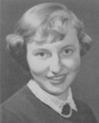

1954 – Betsy (Neff) Cote
betsycote@Atlanticbb.net

1955 – Nancie Anderson (d. 2016)
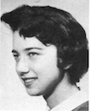

1956 – Edie (Williams) Wingate
WingW@aol.com

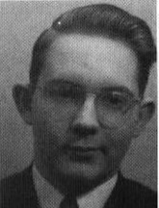

1957 – William Douglas
rwmdouglas@gmail.com

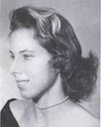

1958 – Pat (Terpening) Owen
nemoamasa@sbcglobal.net

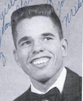
1959 – John “Mike” Hall
MGHall446@gmail.com

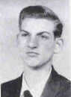
1960 – Ren Briggs
rpbjr@frontiernet.net

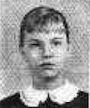
1961 – Betsy (Schley) Slepetz
bslepetz@comcast.net

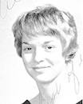
1962 – Dona (Hale) Ritchie

Dona.Ritchie@att.net

_____________________________________________________________________________

A little reminder to all –if/when you change your email address, please let Pat Terpening (58) Owen nemoamasa@sbcglobal.net or me know, if you want to continue to receive the newsletter. Too many times we only find out when you send us an email saying you haven’t received the newsletter in few months. Thanks, guys.
_____________________________________________________________________________

Classmates Who Have Transferred to the Eternal Duty Station
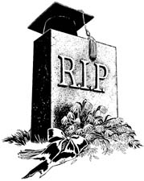

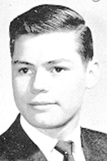
From: John Stephens (62)

This is an obit article about a high school classmate [Charles (Chuck) Nole (62)] who was a class clown – a very, vey funny guy. Then he joined the military and became a hero.

John

###

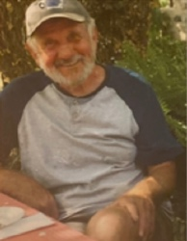
Robert James Gerber (62)

Robert (Bob) passed away peacefully, at Grey Bruce Health Services, Owen Sound on Monday, December 27, 2021, at the age of 77. Bob was beloved husband of the late Chris, dear father of Arthur Gerber, Alisa Piekny, Elena Gerber, and Kirsten Piekny, and proud grandfather of Eric, Jasmine, Jacob and Ava.

Bob was born in New Ulm, Minnesota and eventually settled in Big Bay, Ontario. He had a successful career with IBM and his work took him to many places including Chicago, London (England), and Toronto among others. He enjoyed sports, exploring the wilderness, visiting new places and experiencing new cultures including developing a love of jazz music. With his wife Chris, they built their ‘dreamhouse’ on 100 acres in Big Bay, near Owen Sound, Ontario. Their land bordered the Bruce trail with amazing views overlooking Georgian Bay and the Niagara Peninsula. They enjoyed spending time with other members of the community, and Bob kept busy gardening and bird watching along with BBQs and visits with neighbours. Of course, anyone who knew Bob knew that he loved dogs, and he and his family had many over the years. In recent years his favourite breed were the fun-loving, slobbery newfies that he took on endless walks and who enjoyed winter the most. First and foremost, he prioritized family and friends. He would visit his family in the US, who are scattered across several states, and was particularly close to his sister Mary. He was a loving father and grandfather who was selfless and provided support whenever it was needed. He accepted others readily and was quick to volunteer and help others in need. Up until the very end he was always thinking of others, and many people will have their own special memories of Bob. He will be sorely missed.
A memorial service will be held at a later date with details to be announced.
Memorial donations to the Bruce Trail Conservancy would be appreciated by the family.

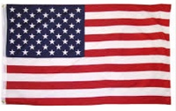
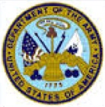

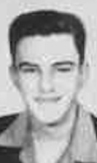
Stephen (Steve) Warner (58)

Stephen Dwight Warner was born on May 12, 1940, to Victor E. Warner, Jr. and Harriette Warner (nee Dwight) in Salt Lake City, UT. The son of an Army officer, he grew up with younger brother Jeff and younger sister Randy in Hawaii, Germany, England, California, and Northern Virginia. He graduated from McLean High School in 1958 and attended the United States Military Academy at West Point where he played soccer and was active in the Parachute and Russian Clubs. After graduation in 1962 he was commissioned in the Infantry and attended Airborne and Ranger Schools.

He began his Army career in the 1/505th Infantry Regiment of the 82nd Airborne Division as a platoon leader, before returning to Ranger School as an instructor at the mountain phase camp in Dahlonega, Georgia. He first saw combat in 1965 while serving as a Battalion Advisor to 25th Infantry Division Army of the Republic of Vietnam, followed by a 6-month tour extension to serve with the Vietnamese Airborne Division as a Battalion Senior Advisor. In 1967 he attended the Infantry Officers Advanced Course and Pathfinder School at Ft. Benning, GA, before returning to Vietnam in 1968 with the 1st Cavalry Division as a Company Commander and serving a second 6-month extension with the 1st Cav as a Battalion Executive Officer. From 1970 to 1974 he served in Washington, D.C. as training staff officer with the Defense Language Institute and at the Pentagon. In 1974 he was assigned to Riyadh, Saudi Arabia as tactical advisor and staff training officer for the Saudi Arabian Army National Guard Modernization Program. He later served with III Corps headquarters at Ft. Hood, TX as the Chief of Officer Personnel Management, and as the Chief of Reserve Component Training and Command Plans Officer for Corps Support Command at Ft. Bragg, NC. Steve then transitioned to the Army Reserve and retired as a Lieutenant Colonel.
His decorations include the Bronze Star with 3 oak leaf clusters, Air Medal with 2 oak leaf clusters, Meritorious Service Medal, Vietnamese Cross of Gallantry, Vietnam Service Medal with 7 bronze stars, Combat Infantryman’s Badge, Ranger tab, Senior Parachutist Badge, Pathfinders Badge, Vietnamese Honor Jump wings, and 6 overseas bars.

He began his Civil Service career in 1980, returning as advisor to the Saudi Arabian Army National Guard Modernization Program in Riyadh until 1983. After a three-year assignment in Atlanta, GA, he moved to Germany where he remained for 15 years with assignments in Darmstadt and Grafenwöhr, working in joint multinational battle simulations for the 7th Army Training Command. Steve retired to Tampa, FL in 2002.

Steve was a legendary world traveler. We find what is called a “compass rose” drawn on maps, used in electronic navigation systems, carved in memorials, and referred to in literature, to designate the four cardinal points, or directions, of north, east, south, and west. Steve Warner had his own compass rose.

The first point of his compass rose is “The Academy,” that is, West Point. And Steve’s North Star was the speech delivered by General Douglas MacArthur on May 12, 1962, the day of Steve’s birthday. The General’s address was titled “Duty, Honor, Country,” the motto of West Point that became the cornerstone of Steve’s life and beliefs.

The second point is the Potala Palace, in Lhasa, Tibet. Steve’s childhood dream was to visit this destination. He credited it for sparking his lifelong passion for travel, and it was a site to which he made multiple pilgrimages.

The third is Pitcairn Island, which held a special fascination for Steve. One of the remotest locations on the planet, in the middle of the South Pacific Ocean and thousands of miles distant from New Zealand, French Polynesia, and the coast of South America, Pitcairn also came to stand for other remote islands he visited: Lord Howe Island, the Cocos (Keeling) Islands, the Australian Antarctica Island of Macquarie, to list only a few. Steve traveled to all 193 countries recognized by the United Nations, and a total of 324 unique global destinations designated by the Travelers Century Club, the membership organization of some 1,500 devoted travelers from around the world.

The fourth point on Steve’s compass rose is the agricultural village of Old Corinth, Greece, which came to symbolize the extraordinary gift Steve had for deep and long-lasting friendships with so many people everywhere in the world. For example, the bonds he made with fellow Eagle Scouts while a teenager living in England matured into a lifetime brotherhood of inseparable friends, no matter that they lived on several different continents. Then there was Ruby Abercrombie, the hospitable local woman who always gave the young Second Lieutenant a warm welcome at her dinner table in Dahlonega, GA while he was at Ranger Camp, and Steve never forgot her kindness. And for more than 50 years, he shared his friendship, support, devotion, and unquenchable zest for life with the simple farming family in Greece living in a world so different from his own. In every place on earth Steve visited, there are friends who love him and honor him.

Steve is predeceased by his brother, Jeffrey Knight Warner (USMA Class of 1964), and survived by his sister, Randall Victoria; sister-in-law Gloria; daughters Stephanie and Linda; niece, Michelle; nephews, Michael and Tasso; and by his life partner, Sally McNally Shimell.

Steve Warner’s epitaph at Arlington National Cemetery will read, “Soldier, Patriot, Traveler.”

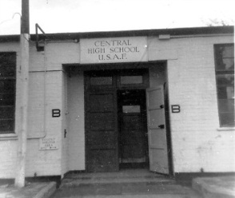
Memories of Bushy Park

Robert Harrold (60) maintains a Bushy Park website at BushyPark.org Among the things you can see at this website is a “Guestbook”, in which many website visitors have left comments. There are many entries, dating back to April 2007.
Here is a direct link: Bushy Park Guest Book


Letters to the Editor

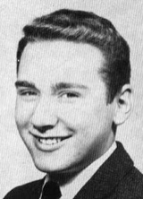
From: Ward Wescott (61)

Hi Pat:

Keeping with your theme (above), here are some words for our classmates.
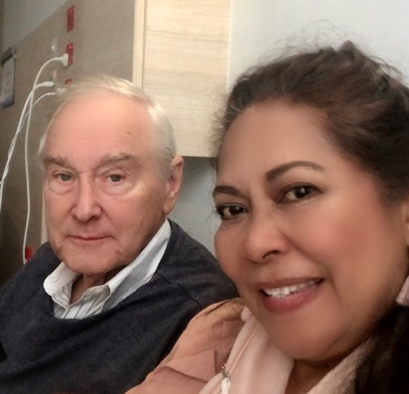
Yes, being expatriated at a relatively young age was interesting and exciting (despite the delayed gratification with respect to not being allowed to drive at 16) and in my case, continues to determine my life and choices. I have a split family, half in the US and half in Australia. Two sets of grandkids and have ended up in what I think is one of the very best environments anywhere for living: beachside Sydney with just a 30 min. ferry ride to the Opera House. You will have a yearbook image of me back then, and here is a photo of Sokee and me today.

I am still in touch with a few classmates (Craig Sams, Noni Kripal nee Hoagland, my prom date, Mike Mortensson, John Hoberg, but not recently. I hope he is still with us!) but we are very widespread and the only Bushy alum I know of living in Australia (Brian McDuffie) passed some years ago.

So, attached is the note:
Kind regards, Ward Wescott (’61)
*
Having read some recent comments on sailing to the UK on the SS United States, I am reminded of some salient memories of my own crossing. Also, Pat, you asked for reflections on how our time at Bushy has influenced our lives since.

The Crossing:

In 1958, we too travelled to England on the SS United States, and we had the good fortune to be travelling first class. I was age 15 at the time and found the prospect of venturing forth into the much wider world than I could access in my hometown of Portland, OR quite exciting.

But there were no kids in first class, and this was my first experience on a ship. Fortunately, there was one young male, age 19 travelling with his mother, and he had crossed the Atlantic a number of times before. He even had his own Tuxedo!!

Yes, there were rules and rigidities as between the classes of travel, but this kid had it all figured out. After dinner, we would take our leave from our parents in first and make our way down to tourist class, as that was where we could find young people dancing and having a good time. To my shock and delight, the alcohol was flowing quite freely and the idea of having to show ID seemed not to apply. So that was my first experience with drinking and being treated as an adult in that respect. Basically, I had a good time mixing and mingling and always got back to my cabin safely, if not very early.

How my life was changed by my experience at Bushy and living abroad:

Dramatically, in a word. We were civilians and lived in Walton-on-Thames, Surrey about a 40-minute ride on the school bus. On the bus I met Brian and Mike McDuffie (both now unfortunately deceased) who lived nearby and whose mum was English while their dad was in the American military. Brian and Mike were very well experienced at life in England and quickly accepted me into their social group and showed me around their idea of life in the UK. I experienced coffee house discussions, pubs, jazz clubs (trad) and parties and was never short of some evening/weekend activities of a social nature. Once again, the drinking age limit seemed not to apply.

More importantly, I noticed a fairly dramatic shift in our family living standard in the UK as compared with back home. It was clear to me that the company took rather good care of its expatriated families as a result of which I aspired to become one.

Having resolved that I, too, would like to live and work abroad, I started taking French at Bushy. And, with the help of the school counselor, was able to research the names and types of companies which had numerous expat executives posted abroad. The big banks came out as pre-eminent in that research. That gave me a steer towards my eventual career.

After graduating from Bushy (1961), my university days started at the U. of Washington in Seattle. Besides my business major, they had a program which would let me study abroad for a year and transfer credits back to UW. For my junior year, therefore, I went off to Paris to the Sorbonne and with the additional help of some side courses at the Alliance Francaise, managed to emerge as a speaker of reasonable French. However, the credits I assembled were translated as liberal arts credits at UW, and to graduate in the business school would have cost me an extra year. So, I transferred to the Economics Department where I could better apply those credits towards a degree and was able to graduate in Economics.

Next, I sought an additional language, and headed to Germany the following year studying at the Goethe Institut and then at the U. of Munich. I returned to focus on Economics and enrolled in the graduate MA program. I also started interviewing and Citibank (then First National City Bank) offered an international career which was exactly suited to my objectives. Besides, they would provide a tuition reimbursement plan to assist my further attendance at NYU studying for my MBA (International Banking and Finance) while working concurrently.

I spent the next 23 years in international banking with Citi, in 6 countries on 4 continents, ending up in Australia where I have settled and remain happily married to my wife, Sokee to this day.

Thus, my experience at Bushy and in England inclusive of my early days travelling in Europe, dramatically influenced my career choice and determined the life I have enjoyed ever since.

###

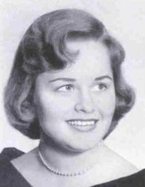
From: Patti Fawbush (58) Webb

Dear Bill,

I have enjoyed the memories of my classmates' overseas trips. Our family went overseas with my father two times. The first time was to Brazil (1947) when I was 7 years old. I still have vivid memories of the flight to Brazil. My father had gone ahead to find us living quarters. He rented a large home not far from the famous Copacabana Beach. This home came with a maid/nanny and a cook.

My mother, my brother and I boarded a military plane to Trinidad where my father met us. We then boarded another military plane, but this time there were no seats, just places to sit along the sides of the plane. My time in Brazil was memorable. I went to an American School in Rio De Janeiro.

In 1950 when we returned to the United States, we boarded the SS Argentina cruise ship. I was only 10 but I remember the wonderful dinners. One dinner in particular stays in my mind. The black-tied waiters paraded in with flaming baked Alaskas high above their heads.

I also remember the swimming pool, and another child I met. I am not sure how we met, but she was in second class, and I was in first class. Therefore, we could not be in the same swimming pool. That was a sad memory but one I can't erase.

When we sailed into New York City and saw the Statue of Liberty even as a ten-year-old my emotions overcame me. What a sight!

Our trip to England was quite different. Again, my father went ahead to find us housing. Our family lived with relatives in Knoxville, Tennessee. The day we left to join Dad we boarded a train in Knoxville. My two aunts and an uncle worked at Standard Mills. As the train left the city, we passed right by the mill. My relatives stood waving to us from the windows. That memory, even as I pen this brings tears to my eyes. My hand grew weary as I longed to keep waving goodbye even as they faded from my view.

When I returned home from England to attend Carson Newman College in Tennessee, I then went ahead of my family. I boarded a military flight home to where my uncle could meet me. Unfortunately, I missed sailing back to the United State with the rest of my family.
Patti Webb
Co-author: Mother's Garden of Prayer & Woman's Garden of Prayer
Hermitage, TN

From: Pat Terpening (58) Owen

Sometimes classmates will ask me if I’ve been able to locate another classmate, and when I haven’t found them, I keep a note next to their name that another classmate is looking for them.

Andrea Kovich (62) had asked me years ago if I’d been able to find Lynn Shea (62), who had been a dorm roommate of hers. I hadn’t, but I had the note. Recently, Andrea contacted me regarding a couple of other roommates of hers, and I did have information on them, and was able to reconnect the three of them. She again asked about Lynn, but still had no info, but I asked Andrea if she had anything I could use. She’d lost contact with Lynn in the 1990s, she said her recollections were slim but did remember Lynn’s father’s name and rank and branch of the military and that she had a half-brother about 8-9 years younger. Also, that Lynn was Canadian and gave me another surname that she used and that she was from a particular town in California and that she’d been a realtor and had married several times. Working with that information, I was able to find several sources using that name and found other information that indicated I’d possibly found her and sent that info to Andrea. She recognized one of the names and I worked on that angle, but I had found another name that I thought might be her, and went with that, and sure enough we found Lynn. Andrea has reconnected with her.

So, if you'd like to reconnect with a classmate, let Pat know who and as much information as you can remember about them. It's really helpful if you possibly know the parent's names, siblings, etc.
Pat

--FINIS--

