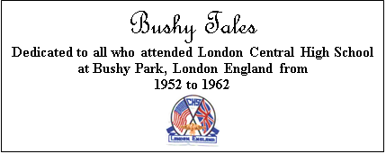

Issue #6 June 2026 Volume #26

Gary Schroeder (55), Founding Editor (1936-2016)
Bill Rumble, Co-Editor email: BushyTales1@verizon.net
Pat Terpening (58) Owen, Co-Founder and Co-Editor email: nemoamasa@sbcglobal.net
Visit the Bushy Park Website at http://www.bushypark.org/

CLASS REPRESENTATIVES
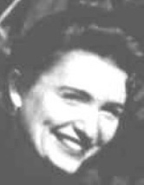

1953 – Marcia (Craver) Thomas

txstarmt@aol.com

1954 – Betsy (Neff) Cote (d. 2024)

1955 – Nancie Anderson (d. 2016)
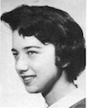

1956 – Edie (Williams) Wingate
WingW@aol.com

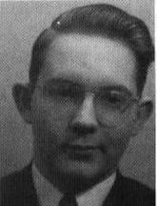

1957 – William Douglas
rwmdouglas@gmail.com

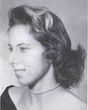

1958 – Pat (Terpening) Owen
nemoamasa@sbcglobal.net

1959 – John “Mike” Hall (d. 2024)

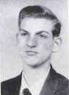
1960 – Ren Briggs
rpbjr42@gmail.com

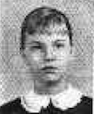
1961 – Betsy (Schley) Slepetz
bslepetz@comcast.net

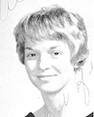
1962 – Dona (Hale) Ritchie

Dona.Ritchie@att.net

_____________________________________________________________________________

A little reminder to all –if/when you change your email address, please let Pat Terpening (58) Owen nemoamasa@sbcglobal.net or me know, if you want to continue to receive the newsletter. Too many times we only find out when you send us an email saying you haven’t received the newsletter in few months. Thanks, guys.
_____________________________________________________________________________

Classmates Who Have Transferred to the Eternal Duty Station
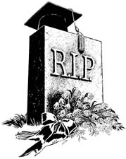

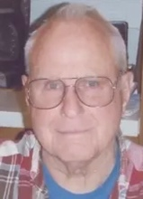
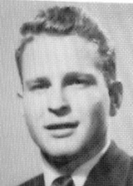
Robert A. Coppa (55)

October 14, 1936 - May 1, 2023

Robert Allen Coppa went peacefully to the Lord at Valley Vista Care Center on Monday, May 1, 2023, with his wonderful care providers at his side. Bob was born on October 14, 1936, in San Rafael, CA, to Joe and Elsie Coppa. He graduated from Bushy Park High School in London, England, and from Purdue University, earning a BA in Accounting. He married his first wife, Barbara, in 1958, and together they had three children, Elizabeth Anne, Robert Allen Jr., and Mary Margaret. They divorced in 1970, and he remarried on November 17, 1972, to Connie (Chudwick) Coppa.

Bob spent most of his life in the accounting/bookkeeping profession in California retiring in 2008 working as a tax preparer for an enrolled agent. He and Connie lived in Rohnert Park, CA, moving to Magalia, CA, in 1975, where he was employed by a CPA firm in Chico, CA. In 1983, the two of them sold everything and went to live on their 30-foot sailboat, cruising the waters of Florida and the Bahamas for the next 6 years. In 1989, they went landside again, living in Bonita Springs, FL, housesitting, with Bob working doing maintenance in an RV park. In 1995, they again returned to their boat life only to have it cut short by Bob’s father’s illness in 1996, which brought them back to Magalia, CA, where they lived until 2008, when they bought property and moved to Pokey Creek Road in Santa, ID. In 2019, Bob was diagnosed with Alzheimer’s, and in 2021, he was moved to Valley Vista Care, St. Maries, ID, for their excellent care of him.

Bob’s interests included sailing/boating, gardening, photography, woodworking, and working on cars, especially Volkswagens. He attended St. Mary Immaculate Catholic Church, St. Maries, ID.

He is survived by his wife Connie residing in St. Maries, son Robert Jr, (Tish) of Coeur d’Alene, ID, and daughters Elizabeth Anne (Frank) of Clarkson, KY and Mary Margaret (Steve) of Oakland, NE, as well as eight grandchildren, fourteen great-grandchildren, and six great-great-grandchildren He is preceded by his parents, Victor Joseph and Elsie Coppa and his brother, Victor Joseph Jr. and wife Tina.

A Funeral Mass was held May 6, 2023 at St. Mary Immaculate Catholic Church with burial following at Woodlawn Cemetery in St. Maries, ID.

###

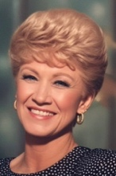
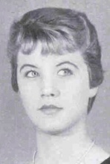
Judy Lee Paullus (59) Laird

June 21, 1941 — April 11, 2026

The beautiful and vibrant Judy Lee Laird, 84, passed away peacefully on April 11, 2026. She was born on June 21, 1941, in Mason City, Iowa, to Alvina “Vicki” Peterson and Rex Paullus.

The family received guests at Schooler Funeral Home, 4100 S. Georgia in Amarillo, Texas, on May 2, 2026, in the Brentwood Chapel. A celebration of Judy's life was held.

Judy fondly remembered her years at London’s Bushy Park High School in England, where her family was stationed with the United States Air Force. It was there that she developed her talent for writing poetry, funny stories, and letters to stay connected to her friends and family (of course, with impeccable handwriting). She was especially proud of being named prom queen her senior year. She carried that same sparkle and charm with her throughout her life.

While in England, Judy married Henry “Lynn” Laird, who was also serving as an officer in the Air Force. Together, they shared daughters Lora Lee, born in Mildenhall, England, and Lisa, born in Canyon, Texas. Though they divorced, Lynn remained an important part of her life story.

Judy later made her home in Canyon, Texas, where she raised her daughters as a single mom and built a life centered on family and friends. She worked for over 22 years at Amarillo National Bank, where she made lifelong friends and was known for her warmth, humor, and vibrant personality. She loved to dance, especially at a local favorite, “The Caravan” in Amarillo, where she enjoyed many happy times two-stepping the night away.

During this time, Judy was delighted to be reunited in 1988 with her birth daughter, Lesley (now Jan), who was placed for adoption decades prior in the UK. She was so happy to have Jan and her family, including two grandchildren, in her life! On two incredibly special occasions, she was able to experience the joy of having her three daughters, plus their families, all together in Texas.

In 1999, she moved to Odessa, Texas, to build a life with Boyce Lay, who became her loving partner for over 20 years. Together they enjoyed a relaxed and happy life, caring for the countless number of dogs and cats (and even birds) that always found a way to their house. Those animals knew exactly where to go for a little extra TLC and, of course, their next meal! Judy had an incredibly special love for animals. Although she loved her life in Odessa with Boyce, she considered Amarillo “home” and was always excited to come back home to catch up with her dear friends.

Judy had a wonderful sense of humor and never missed a chance to make people laugh. She was beautiful, sassy, stylish, and always put together — she had a pair of shoes to match every outfit! She had a special gift for making birthdays memorable, faithfully sending funny birthday cards to her friends every year. She was also crafty and creative, spending hours sewing adorable Halloween costumes for her girls when they were young. She had a special talent for making things beautiful, including decorating packages in ways that made everyone lucky enough to receive one feel extra special.

Christmas was one of Judy’s great joys, and she shared that love with her daughters, who now carry forward those special traditions. She poured her heart into decorating each season, and her Christmas lights were bright enough to light up the neighborhood. One of her proudest moments was being recognized in the Amarillo Globe News for one of the best decorated homes of the year! Her Christmas trees were beautiful, with tinsel hung exactly right and every detail in its place. Her love of Christmas brought so much joy to others, and that meant everything to her.

She loved her family. She especially cherished being “Nana” to her grandchildren, a role that brought her endless pride and joy. She loved each of her grandchildren more than all of the stars in the sky. She is survived by her sister, Connie Jennings of McConnelsville, Ohio. Though they did not grow up together, they shared a special bond and could spend hours on the phone laughing and talking.

Judy was blessed with a loving family, and is also survived by her daughters, Jan Shine and husband, Laurie Shine, of Milton Keynes, England; Lora Lee Laird and husband, Jack Moore, of Plano, Texas; and Lisa Dyer and husband, Rob Dyer, of Georgetown, Texas; and her beloved grandchildren, Dan Shine, Jonathan Shine, Jaxon Moore, Zackary Moore, Madison Dyer, Kennedy Dyer, and Reagan Dyer.

She was preceded in death by Henry “Lynn” Laird and by her longtime loving partner, Boyce Lay.

Judy will be remembered for her beauty, humor, style, sass, creativity, and her love of family, friends, and animals. Her memory will live on in the hearts of all who knew and loved her.

###

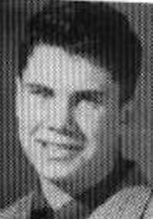
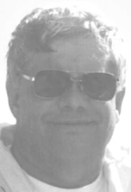
Peter Bruce Clark Burnett (58)

1941 – April 13, 2017

April 13, 2017 Peter Bruce Clark Burnett, 76, a 19-year Vacaville resident, died April 13, surrounded by his family after a brave five-year battle with cancer.

A former banker in Seattle and the San Francisco Bay Area, he also worked for the U.S. Small Business Administration and various non-profit organizations, including Mission Solano in Fairfield.

During his career and in retirement, he volunteered for various civic organizations in the communities in which he lived, and was a member, until recently, of the Solano County Grand Jury. He also enjoyed doing things with his family and international travel with his wife, Robin. A native of Bermuda, he was very proud of his heritage and visited relatives and friends there often over the years. Peter genuinely enjoyed meeting people, and every new face was a potential friend.

Survivors include his wife of 27 years, Robin; his son, Bruce Burnett of Vacaville; daughter, Cristy Burnett Hefner (Mark) of Seattle; granddaughter, Kelsey Rodriguez (Rigo) of Seattle; great-grandson, Luis Rodriguez; and his sisters, Mary Manders (Ken), and Sandy Burnett (Andrew), both in the Bay Area. He was preceded in death by his mother and father, Allan and Enid Burnett, who both died within the last five years in Vacaville.

A private family memorial service was held in June 2017.

###

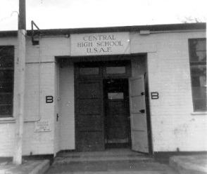

Memories of Bushy Park

Robert Harrold (60) maintains a Bushy Park website at this link: BushyPark.org Among the things you can see at this website is a “Guestbook”, in which many website visitors have left comments. There are many entries, dating back to April 2007.
Here is a direct link: Bushy Park Guest Book

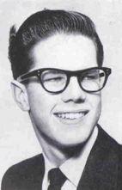
From: Alfred “Fred” Paige Buehler (58)

“Blithe Spirit” - Senior Class Play 1958.

Fred
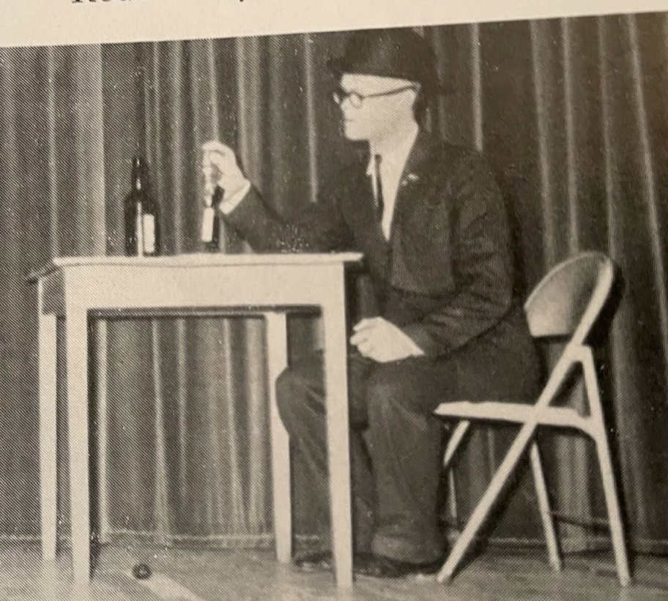

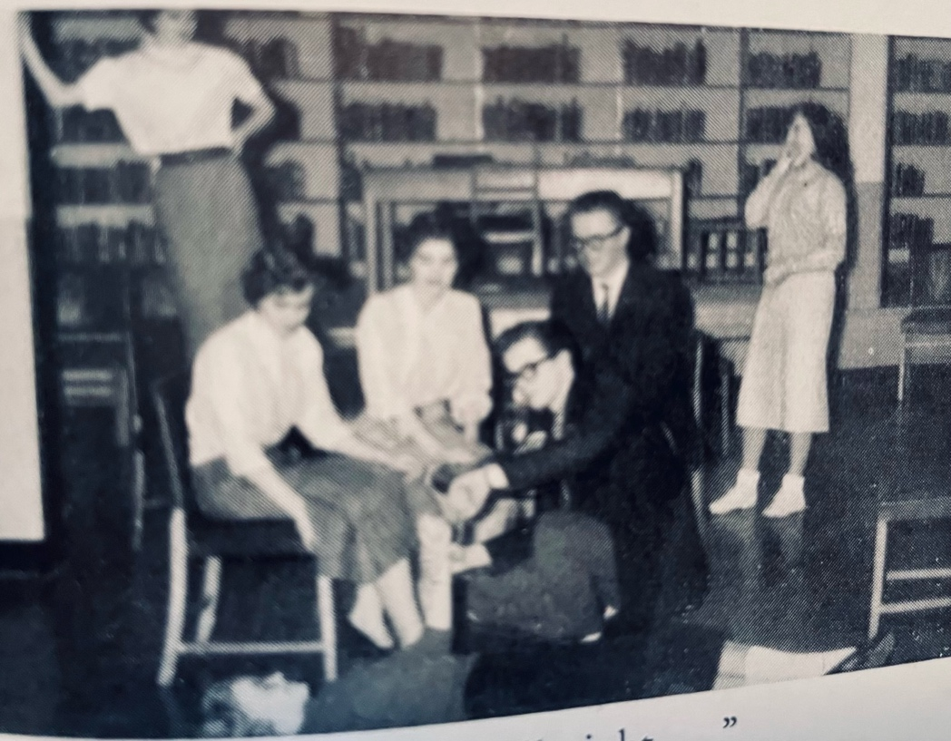


Letters to the Editor

From: Cris “Penny” Ohrman (61) Bernstein

Good morning, Pat. What a beautiful article on Fr. Aaron. He certainly lived a wonderful, full life.

I'm sure there are some interesting people from our days at Bushy. I was only there from Oct. ‘56 to June ’57, then on to Bitburg. Jerry Kelly is still alive, as is Edwina Edwards. We are still in touch. Haven't heard from Karen Cottingham in a while.

Take care and thanks for all you do. I'm still doing the Bitburg communication, etc. We just found out one of what would have been my classmates died in October 2025. He got to BHS just as I was leaving, but met my closest friend, Kathie, at our CHS reunion. That was in July '97, I believe, and they were married in Charleston here at Kiawah that Nov. 1. None of us lived in CHS at the time. I did their wedding and was her matron of honor. It was the anniversary of my mother's death, so I told them, we've made a sad day a happy one. Kathie died 11 years ago, on June 29. It is that time of our lives.

Thought I had a picture of Kathie and me at the Alamo on our birthdays in '15, but here is a picture of her. One of my other friends, Janie, had her birthday on Aug. 4, Kathie's on Aug. 6, and mine on the 7th - we celebrated many together. This was at the Las Vegas reunion I did. I hadn't seen Edwina since Bushy. She surprised me and her and her husband, drove from San Antonio to Vegas to see me - she is in the middle - I'm the far right. It turned out that her friends in Waco before she went to Bushy were the same as Janie's friends in Waco when she came back from Bitburg—had a great time.

Penny
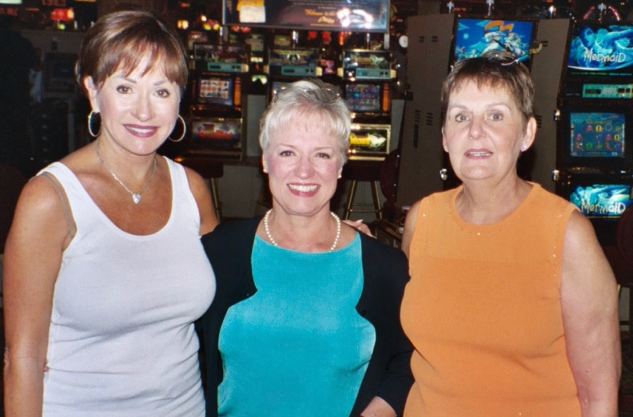
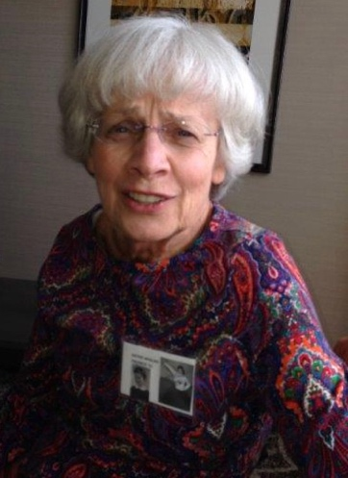

Kathy Janie Edwina Penny/Cris
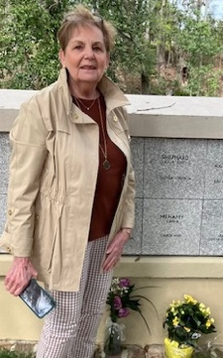
Bill, this is a picture of me in March of ‘25. Unfortunately, visiting another friend’s resting place at Mepkin Abbey here in SC.

--FINIS--

